SOFTWARE REQUIREMENT SPECIFICATIONS

Project Topic: Canteen Automation System

Submitted by: Jamyang Lhashing (12190054)

1. Introduction
- Purpose
Customers will order and collect food in the canteen without having to wait in line thanks to the Canteen Automation System. Customers may skip the line and head directly to the canteen to pick up what they ordered. The aim of this system is to make customer requests and the customer order system that employees use to approve them go as quickly as possible. The system's purpose is to build and implement a simple Canteen Automation System.

- Scope
The project's aim is for users to register using their Gmail accounts and then login using their User Email. It will also use the user's User Email as one of the primary security measures when placing orders in the canteen. After signing in, the user would be able to access the menu and place their order.

2. Requirements
- Functional Requirements :
A. For Admin :
- Login : Admin need to login using valid login credentials to access the system.
- Add Items : Admin can add new food items by specifying details like Food name, Items description, cost, quantity, time to get ready, etc.
- Order Placed : Admin can view items ordered by customers.
- Total Earnings: Total earnings at the end of the day.

B. For Customers/Students :
- Login : Students/Customers need to login using valid login credentials to access the system.
- View Menu : Students can order any food item from the menu.
- Place Order: Students can place orders.
- Total Amount : Students can view total amount.
- View History : A Student can view all their previous orders.

b) Non-functional Requirements :
- Time: In a canteen, the time between the customer placing an order and the cashier receiving it should be as short as possible.

- User-friendly: This app needs to be more user-friendly. The user interface should be uncluttered and plain. Since various types of users would be involved in this process, this project should be simple to comprehend for them.

- Flexibility: This project should be so adaptable that we can easily make adjustments to it whenever we need to.

- Portable: This project should be scalable across all platforms and conveniently accessible on mobile at a faster rate.

- Reusable: All customer applications that are used for customer information should be simple to process so that a large number of customers can communicate with us quickly and efficiently without compromising their information.

c) Software Requirements :
- Windows OS 7 or higher OR Ubuntu 18 or higher
- Android Studio Version 4.1.2
- JDK (Java Development Kit)
- SDK (Software Development Kit)
- Android Version 4.0 or higher
- Firebase

3. Hardware Requirements :
- Memory RAM 4GB or Higher
- 2.00GHz X 4 Processors
- Android Phone

4. System Designs
- ERD(Entity Relationship Diagram)

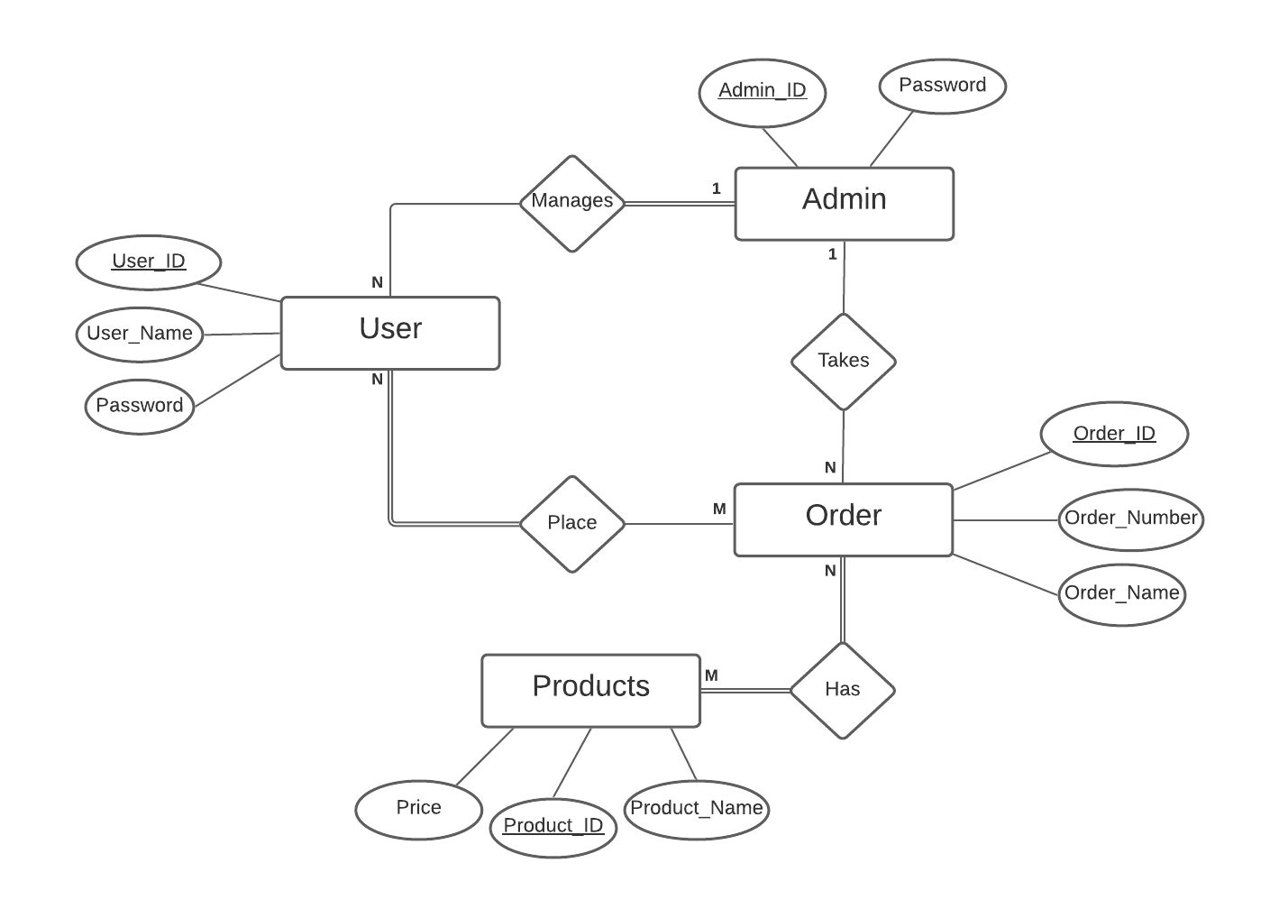
The above ERD has four main entities and various attributes, they are :
- Admin: Admin_ID as Primary Key and Password.
- User: User_ID as Primary Key, User_Name and Password.
- Order: Order_ID as Primary Key, Order_Number and Order_Name.
- Products: Product_ID as Primary Key, Product_Name and Price.

The above ERD has four Relationships between the entities, they are :
- Manages: One Admin manages many Users. Carditionality ratio 1:N.
- Takes: One Admin takes many Orders. Carditionality ratio 1:N.
- Places: Many Users place many Orders. Carditionality ratio N:M.
- Has: Many Orders has Many Products.

- Relational Schema
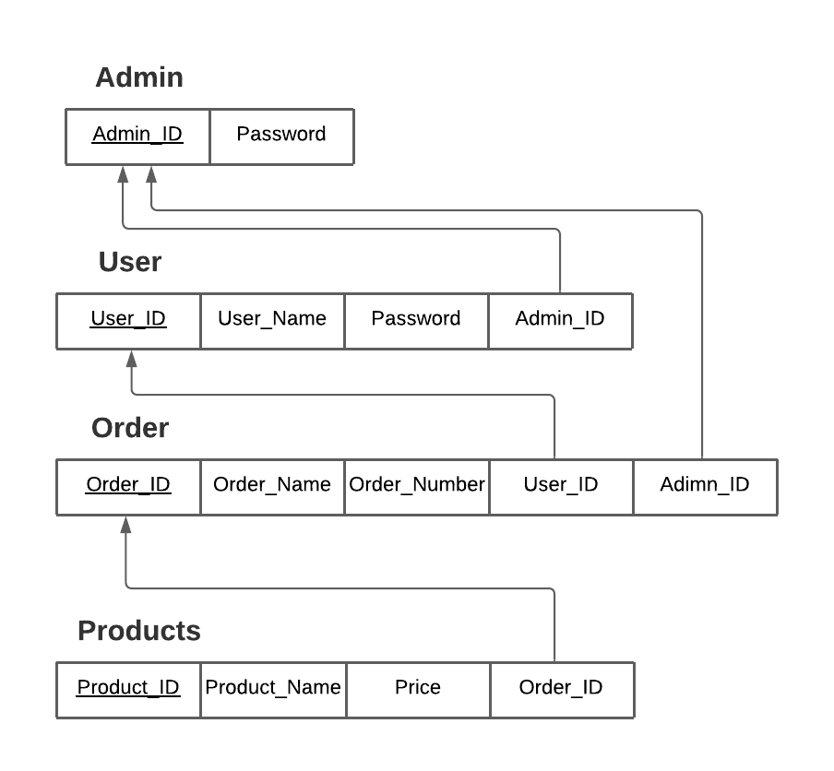
Above Relation Schema have four tables, they are :
- Admin: Admin_ID as Primary Key.
- User: User_ID as Primary Key and Admin_ID as Foreign Key.
- Order: Order_ID as Primary Key, User_ID and Admin_ID as Foreign Key.
- Products: Product_ID as Primary Key and Order_ID as Foreign Key.

- Sequence Diagram
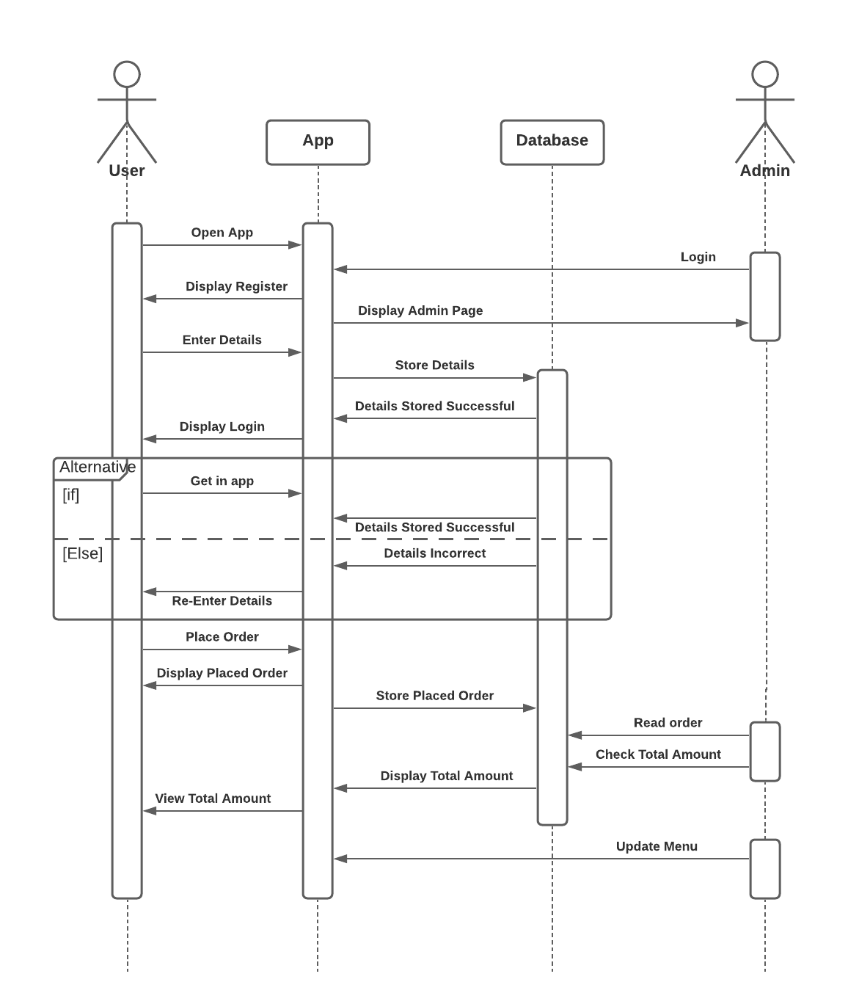
The above sequence diagram shows the system workflow and explains the detailed logic behind Canteen Automation System application.

- Use Case
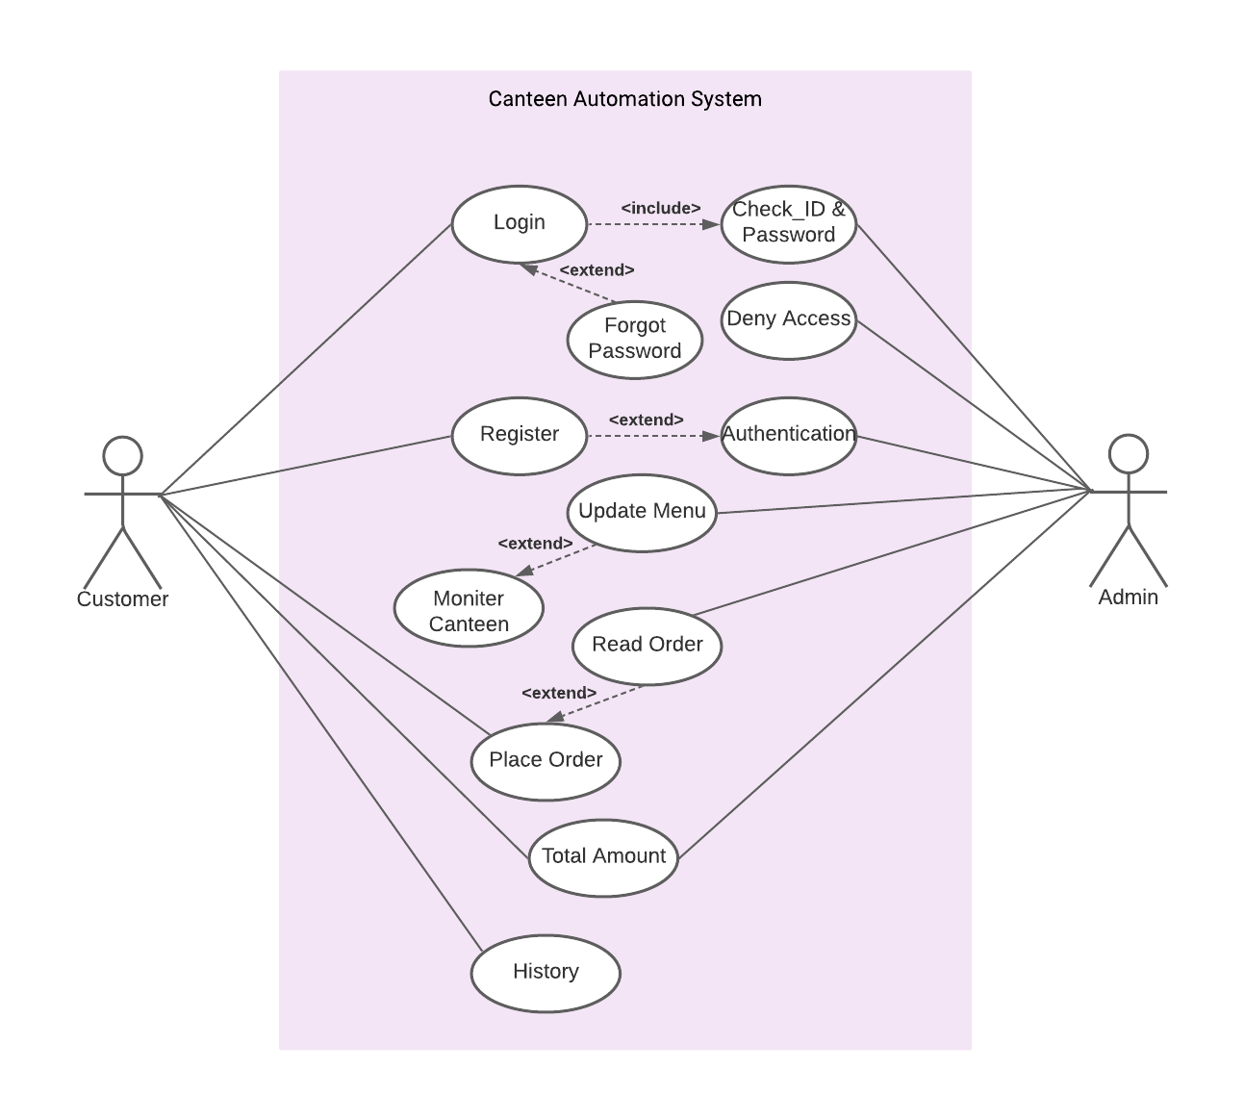
Above Use Case has two actors :
- Primary Actor: Customer/User.
- Secondary Actor: Admin.

Functionalities of Primary Actor - Customer/User can:
- Login
- Register
- Place Order
- View Total Amount
- View History

Functionalities of Secondary Actor - Admin can:
- Update Menu
- Read Order
- View Total Amount

